CSE-326 CA-1

PROPERTY WEBSITE

WEBSITE PROJECT REPORT

# Project done by Team members

CLASS KOC27

1 SHIVAM KUMAR

REGISTRATION NUMBER 12218903

ROLL NO: 60

2 RITIK ROUSHAN KUMAR

REGISTRATION NUMBER 12219024

SUBMITTED TO

MR HARSHIT COPHRA

RENTAL PROPERTY PROJECT

# INTRODUCTION

We create designs in a Collaborative environment enabling us to deliver the client's ultimate vision, our designs are current ,yet still possess a timeless style generating broad market appeal. Our reputation for outstanding service and our innovative design style creates an extremely successful partnership with our clients. Elevate your luxury listings with the spotlight they deserve. Single property websites position your listings to make a stunning first impression. We all know the saying about first impressions. These days, staging and listing a home don’t just boil down to a few professional photos and some fragrant cleaning products. More than likely, the first glimpses that potential buyers steal of your listings won’t be from a drive-by or a tour—they’ll probably take place online. High-end real estate websites pull attention and intrigue to your properties, attracting the buyers you want for your luxury listings.

# OBJECTIVES

1. To estimate the cost-effectiveness of the Houses and Land in the near by areas or the far places to purchase or take it for rent.
2. To investigate the frequency at which prices maximum people are willing take it for average prices.
3. This helps you to find the budget friendly properties which is helpful for poor and middle class people.
4. The main objective of the development of this application is to overcome the problems that exist in the current system.
5. The main objective of developing the system is gather all properties under a single roof, and encourage .

# FLOW CHART

### PATH OF WEBSITE

# PICTURES OF PROJECT

HOME PAGE

THIS PAGE CONTAINS

1. WHERE WOULD YOU LIKE TO TAKE PROPERTY
2. SALES PROPERTIES ETC

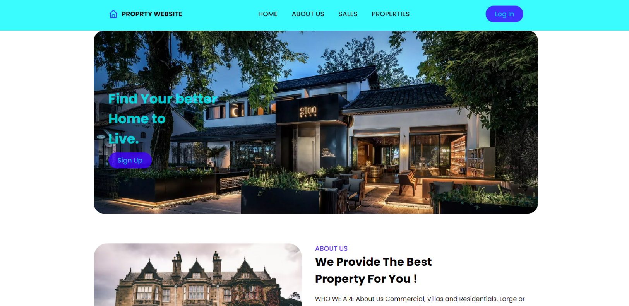

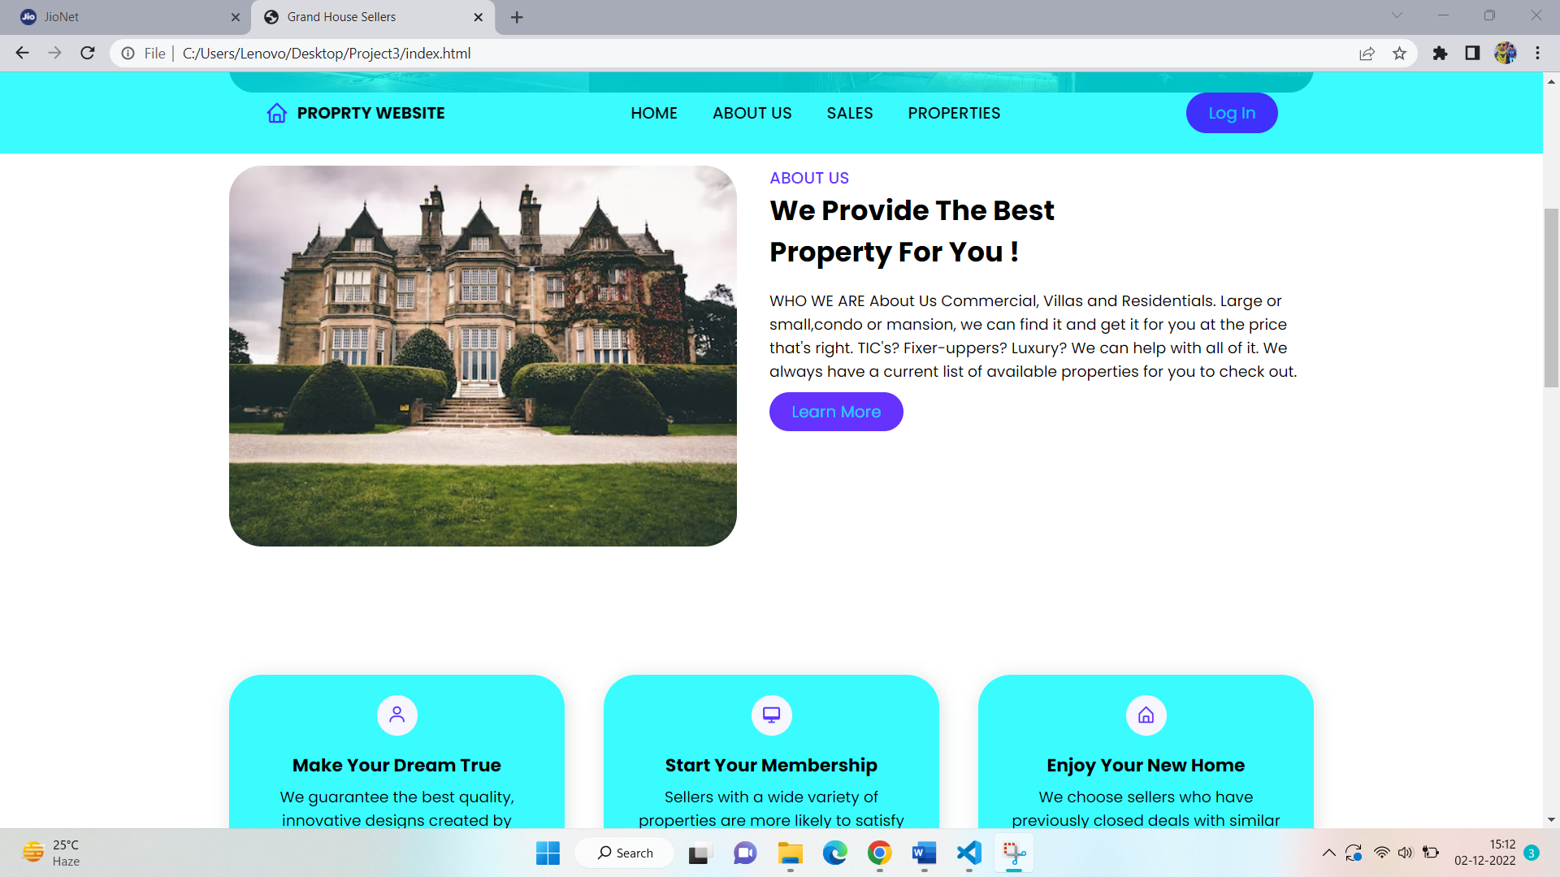

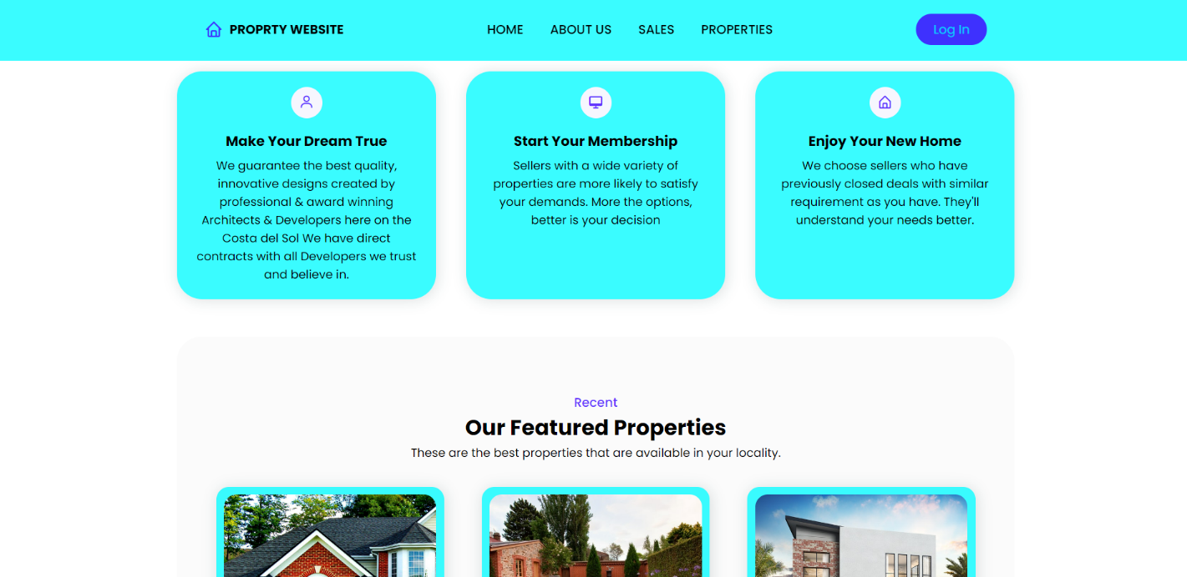

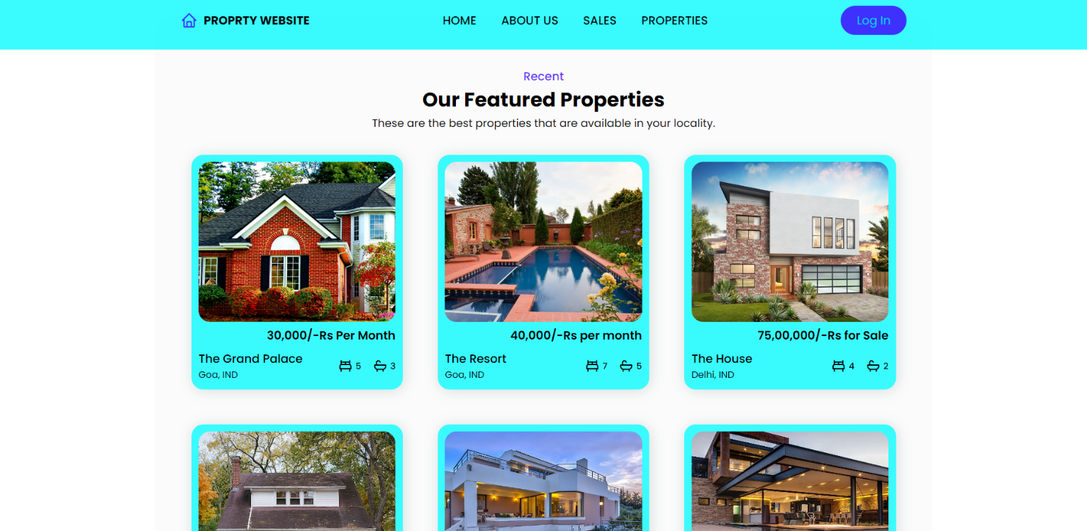

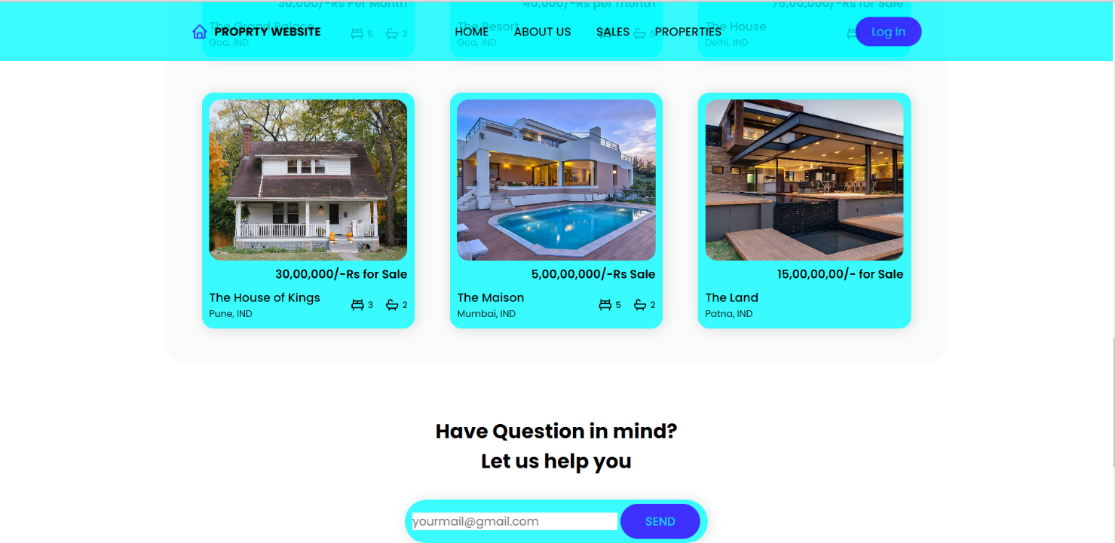

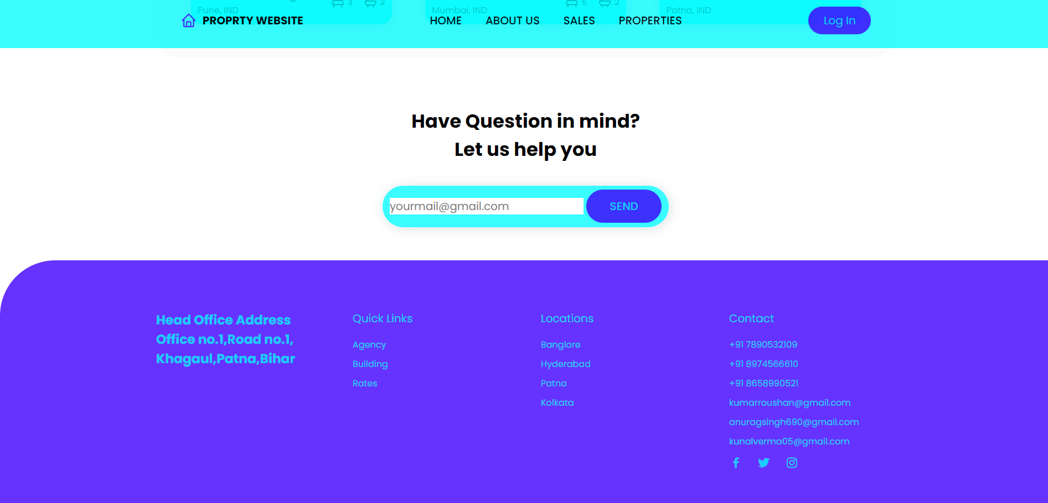

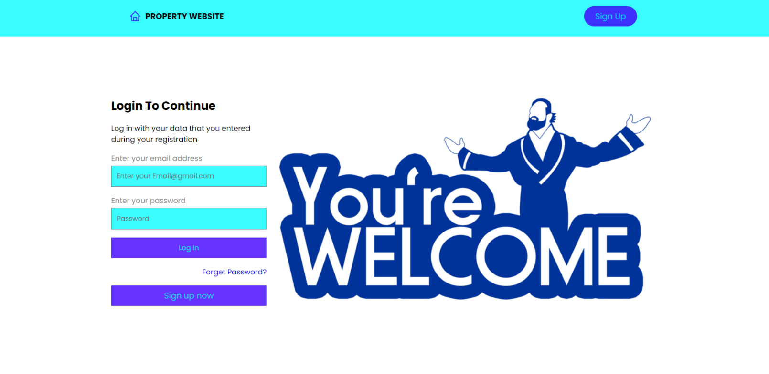

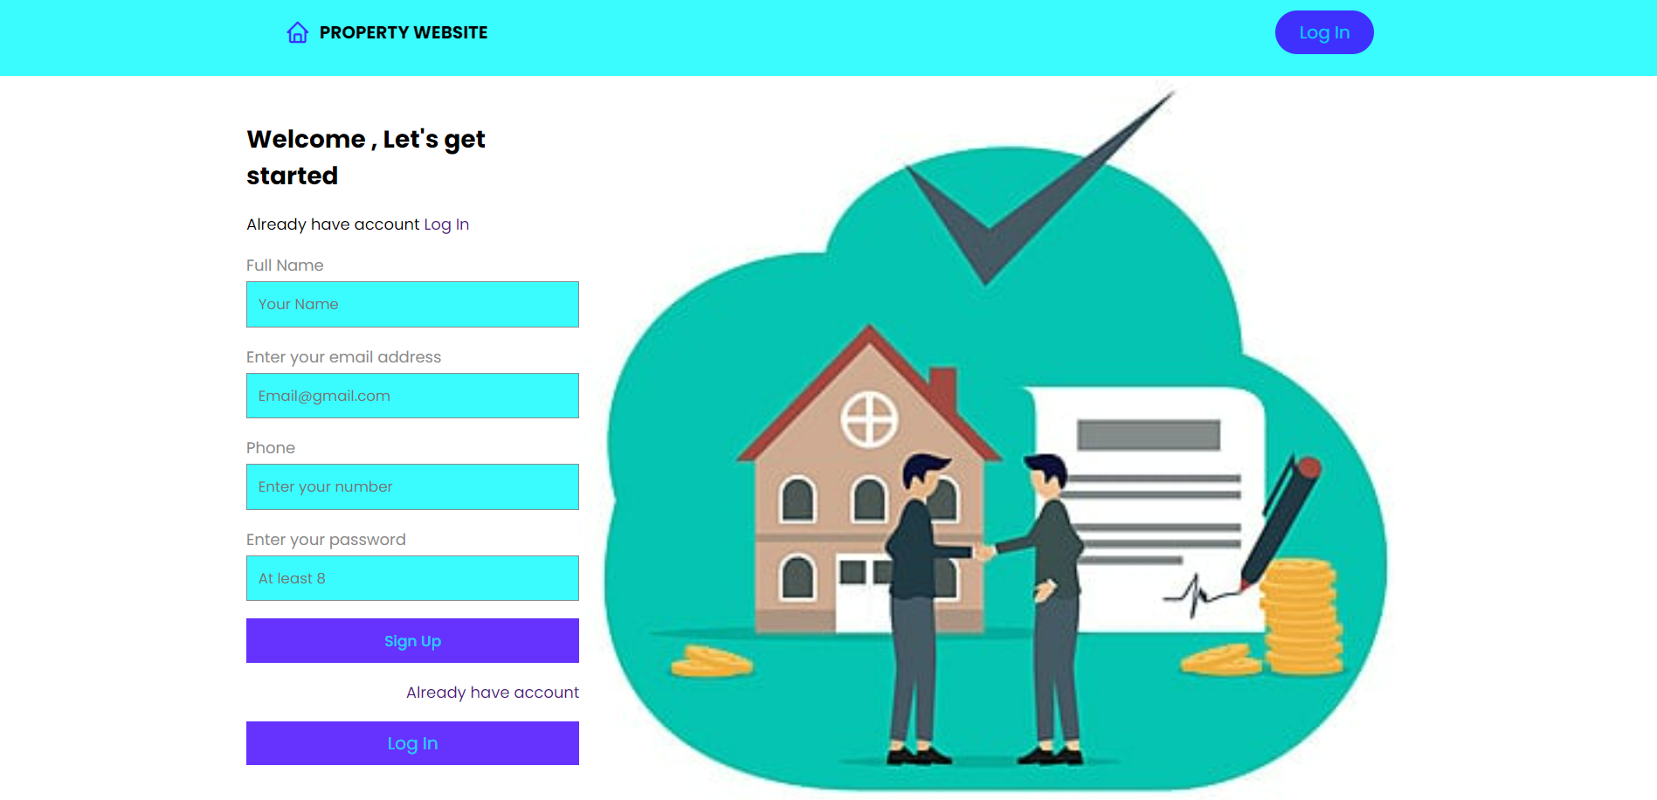

# Conclusion

# In this project I can conclude that way of design and **Implementation of an PROPERTY WEBSITE**

This website helps you to find a property in the place where you need and the prices in it are reasonable which helps all to buy/rent. It also helps you to sell the property or a land at the cost which you like. This app is highly secured to use and make payments. As your relationship with a new client progress, and you’ve got the home out there on the market, your capability to provide needle-sharp analytics and targeted takeaways will not only impress the seller but will also help you understand the market and audience.

FUTURE SCOPE

PROJECT IMPLEMENTATION TO DESGIN A WEBSITE GIVES US A LOT OF SCOPE IN HYPER TEXT MARKUP LANGUAGE AND MAKING WEBSITE DYNAMIC AND RESPONSIVE TO BE USER FRIENDLY CASCADING STYLE SHEETS WHICH IS USED GIVES A GOOD DYNAMIC LOOK FOR WEBSITE AND TO GET MORE INTERACTIVE .

THANK YOU